https://www.shiftelearning.com/blog/bid/351150/10-things-that-learners-pay-attention-to-and-how-to-use-them-in-elearning

10 Things That Learners Pay Attention To (And How to Use Them in eLearning)
BY Karla Gutierrez29, SEP 2017
Even more than other types of education, eLearning must struggle to attract learners' attention: the Internet is full of distractions, and adult learners are both busier and more free to indulge in distractions. Helping students to pay attention is a primary concern of training professionals, so here are some optimal methods to win the attention game.
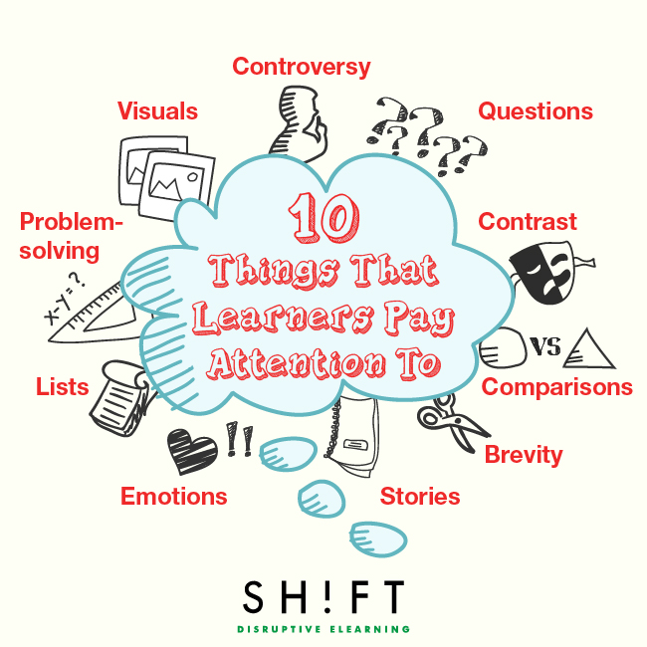

1. Problem-solving.
Adult learners are almost always taking an eLearning course for a specific purpose rather than just for fun. Focus on giving them what they want: answers to their real-world problems. You should be able to put yourself in the learner's position and respond to the question, "What's in it for me?" If you truly want to grab their attention, you’re going to need to have answers to this question especially. After all, people will pay much more attention to aspects they consider relevant to their own lives and past experiences.
Grab your learner’s attention instantly by presenting a problem that keeps them reading. Headlines are a good way to apply this strategy: present your lesson as a "How-to," laying out clearly what problem the rest of the lesson or module will solve. Dominant headlines, especially when placed in the upper left corner, typically draw the eyes first. In fact, they also tend to capture attention faster than images. Make headlines meaningful to help your learners find the content they need easily. Keep them relevant, simple, concise and irresistible.

2. Comparisons.
Studies reveal the brain pays more attention to what’s new or different. It's natural for people to get curious about something new, foreign, weird, unpredictable or different. When eLearning content is surprising or unexpected, ignoring it becomes impossible. According to Carmine Gallo's blog "Why TED Talks Are Impossible to Resist," experts in the subject explained that “Our brains are trained to look for something brilliant and new, something that stands out, something that looks delicious.”
To get your learners to pay attention for a long time, you need to keep giving them new things to think about, but obviously, you don't want to stray too far from the topic. Making a comparison, simile, or metaphor helps focus attention. Plus, if you refer to a familiar aspect of the learner's life, they may find it easier to grasp your point.

3. Visuals.
A picture, as they say, is worth a thousand words. People are naturally inclined to pay attention to images because they are easier to digest and faster to understand than large blocks of text.
Use an image to draw learners in and set the tone of the lesson, then use other visuals to add meaning to your words. Both showing and telling your message doubles its impact.
Also, start replacing long chunks of texts with relevant visuals. In fact, a Nielsen study finds users pay attention to “photos and other images that contain relevant information, but ignore fluffy pictures used to “jazz up” pages.”

4. Questions.
Questions invite someone to actively participate in learning rather than just passively absorb data. Asking a question encourages people to think and reflect about what they're learning, which helps them not only retain more information but also learn strategies to use what they've learned. Plus, it feels good to solve a problem on your own.

5. Emotions.
Emotionally-charged stimuli capture people’s attention immediately. On top of that, the brain remembers an emotional experience better than anything else. In eLearning, you can make this work for you by encouraging emotional response. Many of these tools, such as compelling stories, videos, images, and visually engaging screens can evoke emotion; try to connect emotionally with learners, and they will learn more and better. Create shocking, impressive or surprising moments that grab your learner’s attention right away.
Also read:
How to Stimulate Learner Emotions to Make Maximum Impact in eLearning
Want to Design Emotional eLearning? Understand The Role of Emotions in Learning First

6. Stories.
Storytelling is a natural human brain pattern: stories are better remembered, better understood, and simply more listened to than other forms of communication. If you craft your lesson into a simple narrative, people will be more likely to listen to the whole thing and much more likely to remember it later.
Try not to force the point too hard: people feel more engaged if they can come to their own conclusions. As the saying goes, "Show, don't tell!"
Read more: How Storytelling Can Improve Your eLearning Courses

7. Contrast.
Are there any elements here that are in contrast to things that came before? The human brain asks this question on a regular basis. It's hardwired to look for contrast as if its survival depends on it. Truth is the brain will always pay more attention to things in contrast to other things.
Boredom, most of the time, is produced by stasis, so keep things moving to encourage learning. There's no need to be too obvious about it; subtle changes of font can be more effective than switching the whole color scheme. The goal isn't necessarily to be consciously noticed, but rather to focus the brain's natural priorities.
Read more: The Science Behind What Makes an eLearning Design Effective

8. Controversy.
There's nothing like a small shock to get people's attention, so start off your lesson with a fact, statistic, or statement that will startle readers. There's no need to get too extreme, but leading with the most shocking information is a good way to grab attention. Hard measurements are ideal here, percentages and dollar values especially, to get people thinking. Rather than save your conclusion for the end, consider starting off with it, so people will want to know how you got there.

9. Brevity.
People, especially adult learners, are busy, and they'll appreciate it if you make your information as easy as possible to skim. With so much information out there, skimming helps decide whether to put in the time to read the whole thing. What's more, learners prefer shorter, bite-sized pieces of information because they cannot sustain attention on a task for an extended period without pause. That's because of the ebb and flow of our energy. A study, in fact, revealed that the average attention span online is about 8 seconds.
Instead of spending 90 or more minutes taking a course, learners will enjoy consuming short, snappy yet meaningful content. Organization is key: headings and subheadings provide a clear outline. Also, keep paragraphs short and simple, with 3 to 4 sentences each and no unnecessary words.

10. Lists.
Numbered lists create a sequence of events, offer a mini-table of contents, and set an up-front expectation that adult learners find extremely attractive. Plus, lists help break down information into bite-sized chunks. They do as much to keep you organized as to keep the reader interested. In short:
- Lists make it easier for readers to consume most of your content.
- They discourage distraction and help readers make sense of your content quickly.
- Provide a visual break for your learner.
Combine these strategies, and you will quickly see a dramatic increase in your eLearning effectiveness.

