5 Important Rules of Typography for E-Learning Designers
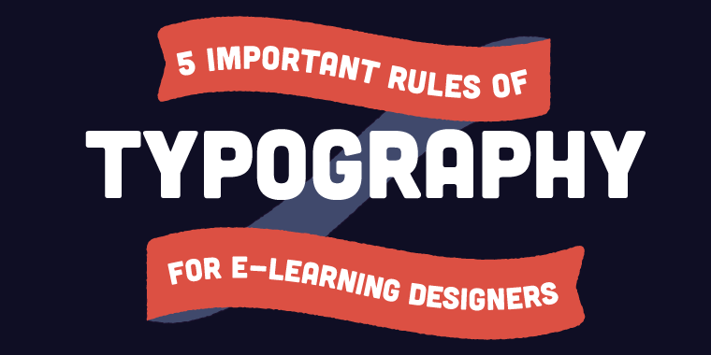
For e-learning developers, typography is an important element of design because so much of our courses are composed of the written word. How many courses can you think of that contain zero text? None, right? Text is one of the primary ways (along with audio, video, and images) that we convey information in e-learning. With that in mind, it’s important to know some basic rules of e-learning typography when you select fonts for your course designs.

Choose a Font That Matches Your Subject
It’s important to remember that certain topics and subject matters work well with certain fonts, and vice versa. A fun course for children or teens on a lighthearted subject could make use of a cute, decorative, or whimsy font. That same font would not work so well for a serious financial course. Your font style should match your content. Take a look at the fonts below to see how confusing it can be when the font doesn’t match the content. 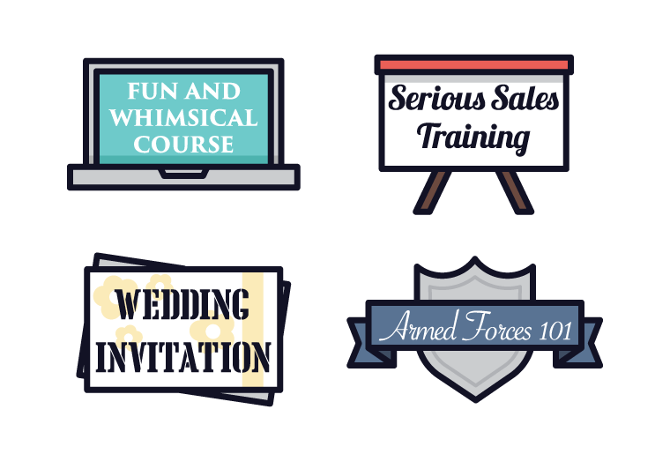If you’re not sure which fonts work with your subject matter, try looking online. Do a keyword search and look at Google Images to see what types of fonts are highly visible.

Mix and Match Fonts Appropriately
When using multiple fonts, it’s important that they enhance each other.
Do
- Pick one thick and one thin font; they balance each other out.
- Select fonts that are easy to read.
- Choose fonts that allow for proper capitalization.
- Use decorative fonts for titles and headings; simpler fonts for body text
Don't
- Pick fonts that will compete for attention.
- Use fonts that are illegible or difficult to read.
- Use fonts that are too similar (for example, don’t use two handwritten fonts or two chunky fonts).
- Mix and match more than two or three fonts in one course.
Take note of the mix-and-matches below. Take notice of how some fonts work well together, while others don't.
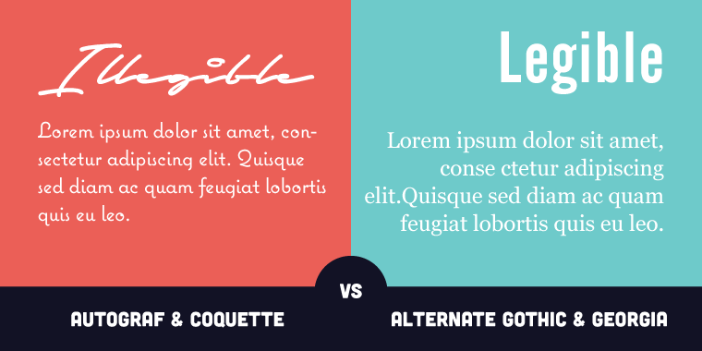

Line Spacing
Line spacing is important, which is why Articulate Storyline 2 offers you the option to set specific line spacing. There’s no need to leave the default spacing as is when you have the flexibility to customize your line spacing down to the pixel! Fine-tune your line spacing to ensure everything is spaced evenly and consistently, with a nice amount of white space all around.

Choose the Right Font Size
This is a straightforward point but one that’s really important. Make sure that all your course text is large enough for learners to read it easily. And remember that when something is written in huge letters that stand out, learners take notice, so put your important messages in larger letters (in moderation, of course!).

Alignment Is Critical
Those with a keen eye for design can spot alignment issues from a mile away. An easy way to help solve your alignment issues is to use grids and guides in your designs to ensure your text is lined up.
Another important tip is to remember that left-aligned text is much easier to read than centered text. Now, it’s usually no biggie for learners to scan a center-aligned photo caption or button text and get what it means; but anything more than a single sentence, such as paragraphs or bodies of text, should be left-aligned in your courses. You should also try to stick with one type of alignment and be consistent with it throughout your design.
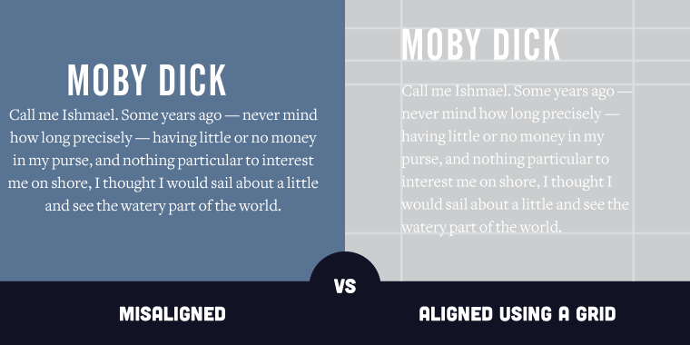
Keep these important tips in mind the next time you choose fonts and add type to your e-learning designs. It has a big impact on how polished and professional the final output will look. Do you have tips of your own about typography? Please leave them in the comments below!
Follow us on Twitter and come bac

